1. Deck and Seating

牌组和座位

• Deck

牌组

• GUANPAI is played with two standard 54-card poker decks (including two Jokers each), for a total of 108 cards.

• 掼牌是以两副标准54张扑克牌（包括两张大小王）总计108张牌作为竞赛工具

• Each player is dealt 27 cards.

• 每位玩家发27张牌

• Table and Positions

• 牌桌和座位

• Four players sit around a square table and are assigned the compass directions East (E), South (S), West (W), North (N), either by random draw or agreement.

• 四名玩家围坐在一张方桌旁，通过随机抽签或协商的方式分配罗盘方向东 (E)、南 (S)、西 (W)、北 (N)。

• Teammates sit opposite each other: East & West vs. South & North.

• 队友面对面坐：东家和西家对阵南家和北家

⸻

2. Card Types and Rankings

牌型及大小比较

2.1 Suits and Jokers

花色和王牌

• Four suits: ♠ Spades, ♥ Hearts, ♦ Diamonds, ♣ Clubs.

四种花色：桃花，红心，方片，梅花

• Two Jokers per deck: Little Joker and Big Joker (total of four Jokers).

每副牌两张王牌：小王以及大王（总计4张王牌）

2.2 Valid Combinations (“Hands”)

有效的牌型

1. Single: any one card.

单张：任意一张牌。

1. Pair: two cards of identical rank (including two Little Jokers or two Big Jokers).

对子：两张牌点相同的牌（包括两张大王和两张小王）。

1. Three of a Kind (“Triple”): three cards of identical rank.

三同张：三张牌点相同的牌型。

1. Sequence of Pairs (“Three-Pair Run”): three consecutive pairs (e.g. 4-4-5-5-6-6).

三连对：三个牌点相邻的对子牌型，如44+55+66。

1. Double Triple (“Plate”): two consecutive Triples (e.g. 7-7-7-8-8-8).

三同连张：两个牌点相邻的三同张牌型，如:777+888。

1. Full House (“Three-with-Two”): one Triple + one Pair.

三带对：一个三同张带一个对子的牌型，如222+33。

1. Straight: five consecutive single cards (Jokers cannot be used) (e.g. A-2-3-4-5).

顺子：五个牌点相邻的单张组成的牌型，如A2345。

1. Bomb: four or more cards of the same rank (e.g. 9-9-9-9, or 6-6-6-6-6).

炸弹：四张或四张以上牌点相同的牌，如:9999、66666。

1. Flush (“Flush Bomb”): five consecutive single cards in the same suit (Jokers cannot be used).

同花顺:花色相同的顺子（不包括王牌）。

1. Royal Flush (“Royal Flush Bomb”): five consecutive single cards in the same suit with A as the highest card.

皇家同花顺:花色相同的以A为最大牌的顺子。

1. Four-Joker Bomb (“Heaven Bomb”): all four Jokers.

四大天王（天王炸）：大王、小王各两张牌。

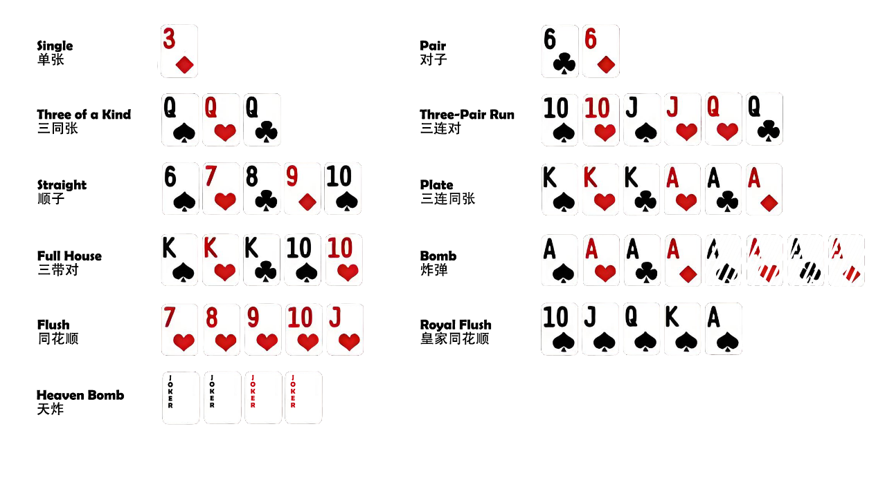

2.3 Special “Rank Cards” and “Heart Rank Cards”

级牌以及红桃级牌

• Rank Card: After each deal, one rank from 2 through A is designated “the Rank.”

级牌：每次发牌后，2至A之间的一个牌点被称为“级牌”。

• All cards of that rank (in any suit) rank immediately below Jokers but above A, K, Q, …, 2.

所有该牌点的牌（任何花色）大于一切除了大小王以外的牌。

• Rank Cards act as normal cards when they are used in Straight, Flush and Royal Flush.

在顺子、同花顺以及皇家同花顺中级牌作为普通牌。

• Heart Rank Card (“Wild Card”): the ♥ of the current Rank also counts as a wild that can pair with any other rank to form the highest possible valid combination—unless you state otherwise at play.

红心级牌（百搭牌）：当前级牌中的红心花色可作为百搭牌，可以与任何其他牌配对，形成最高有效组合 - 除非您在游戏中另有说明。

• Heart Rank Card (“Catch-All”) **CAN NOT** combine with Jokers.

红心级牌（百搭牌）**不能**与大小王搭配使用。

2.2 Some examples of valid Combinations (“Hands”) with Heart Rank Card. (Example Using ♥2 as the Wild Card)

一些使用百搭牌的有效牌型的例子（以♥2为例）：

1. Pair: ♥2+J=JJ.

对子： ♥2+J=JJ 。

1. Three of a Kind (“Triple”): ♥2+♥2+7=♥2+7+7=777.

三同张：♥2+♥2+7=♥2+7+7=777。

1. Sequence of Pairs (“Three-Pair Run”): ♥2+♥2+4+4+5+5=♥2+4+4+5+6+6=44-55-66. Alternatively, you may declare it as ♥2+♥2+4+4+5+5=33-44-55.

三连对： ♥2+♥2+4+4+5+5=♥2+4+4+5+6+6=44-55-66，也可以♥2+♥2+4+4+5+5=33-44-55。

1. Double Triple (“Plate”): e.g. ♥2+♥2+7+7+8+8=♥2+7+7+8+8+8=777-888.

三同连张： ♥2+♥2+7+7+8+8=♥2+7+7+8+8+8=777-888。

1. Full House (“Three-with-Two”): ♥2+ ♥2+K+3+3= ♥2+ ♥2+K+K+K= ♥2+ ♥2+K+K+3= ♥2+K+K+3+3=KKK-33. Alternatively, you may declare it as♥2+ ♥2+K+3+3 = ♥2+ ♥2+K+K+3= ♥2+K+K+3+3=333-KK

三带对：♥2+ ♥2+K+3+3= ♥2+ ♥2+K+K+K= ♥2+ ♥2+K+K+3= ♥2+K+K+3+3=KKK-33，也可以♥2+ ♥2+K+3+3 = ♥2+ ♥2+K+K+3= ♥2+K+K+3+3=333-KK。

1. Straight: ♥2+8+9+J+Q=♥2+8+9+10+J=8-9-10-J-Q. Alternatively, you may declare it as♥2+8+9+10+J=7-8-9-10-J

顺子：♥2+8+9+J+Q=♥2+8+9+10+J=8-9-10-J-Q，也可以♥2+8+9+10+J=7-8-9-10-J。

1. Bomb: ♥2+♥2+4+4=♥2+4+4+4=4444, ♥2+♥2+8+8+8+8+8+8+8+8=8*10

炸弹：♥2+♥2+4+4=♥2+4+4+4=4444, ♥2+♥2+8+8+8+8+8+8+8+8=8*10。

1. Flush (“Flush Bomb”): ♥2+♥2+♥5+♥6+♥8=♥2+♥4+♥5+♥6+♥8=♥4-♥5-♥6-♥7-♥8.

同花顺：♥2+♥2+♥5+♥6+♥8=♥2+♥4+♥5+♥6+♥8=♥4-♥5-♥6-♥7-♥8。

1. Royal Flush (“Flush Bomb”): ♥2+♥2+♣10+♣Q+♣A =♥2+♣10+♣Q+♣K+♣A=♣10-♣J-♣Q-♣K-♣A.

皇家同花顺：♥2+♥2+♣10+♣Q+♣A =♥2+♣10+♣Q+♣K+♣A=♣10-♣J-♣Q-♣K-♣A.

2.5 Card-by-Card Ordering (High → Low)

牌点的大小（从高到低）

1. Big Joker

大王

1. Little Joker

小王

1. Rank cards (all four suits)

级牌（所有四种花色）

1. A, K, Q, J, 10, 9, 8, 7, 6, 5, 4, 3, 2
2. The four suits have no ordering differences.

四种花色没有大小区别

. Note: In sequences, A can act as “1” (e.g. A-2-3-4-5, AA-22-33, AAA-222).

注： 在连续牌型中，A可以作为1使用（例如：A-2-3-4-5、AA-22-33、AAA-222）

⸻

3. How to Compare Hands

牌型大小的比较

1. Same type only: You can only beat a hand by playing the same combination type with higher rank.

仅同类牌型：你只能通过打出相同牌型组合的更高牌点的牌来击败对手。

2. Within-type rules:

• Singles, Pairs, Triples, Three-Pair Runs, Triples-with-Two, Straights, Flushes: compare top card(s).

单张，对子，三同张，三连对，三同连张，顺子，同花顺：以上七种牌型直接根据最大牌点确定大小。

• Full House: compare the rank of the Triple.

三带对：仅对比三同张的牌点大小。

3. Bombs

炸弹

• Any Bomb (≥ 4 cards) beats any non-Bomb hand.

• 任何炸弹（大于4张同样牌点的组合）比任何非炸弹牌型大。

• Among Bombs, the one with more cards wins; if equal size, higher rank wins.

• 牌数更多的炸弹大于牌数少的；如果牌数相同，牌点更高的大。

• Flush Bombs beats any bomb ≤ 5 cards.

• 同花顺比任何小于等于五张牌的炸弹大。

• Royal Flush Bomb beats Flush Bombs.

• 皇家同花顺比同花顺大。

• Bombs of size ≥ 6 can beat a Flush and Royal Flush.

• 大于等于六张牌的炸弹比同花顺和皇家同花顺大。

4. Heaven Bomb (4-Joker)

• 四大天王

• Beats any other hand.

• 四大天王大于其他所有牌。

⸻

4. Dealing, Tribute & Upgrade

抓牌，进贡和升级

4.1 First Deal

首次抓牌

1. Shuffle by East.

东家洗牌。

1. Cut by South and reveal one card (if it’s a Joker or Heart-Rank, re-cut).

由南家切牌并翻出一张牌（如果是王牌或是红桃级牌则重新切牌并翻牌）。

3. First hand: Starting from South, count counterclockwise by pips on the revealed card; that player paly the first hand.

第一手：从南边开始，按被翻开的牌的牌点逆时针数出首抓者；抓到翻出牌者首先出牌。

4.2 Subsequent Deals

后续发牌

• Shuffle by 4th player from last round, cut by the 1st player from last round and deal by the partner of 4th player from last round.

• 由上一轮第 4 名的玩家洗牌，由上一轮第 1 名的玩家切牌，由上一轮第 4 名玩家的搭档发牌。

• If either of last deal’s two lowest finishers (“Tributers”) hold both Big Jokers, tribute is cancelled and the 1st player from last round leads.

• 下游或双下方在进贡前抓到两个大王，则不再进贡并由上一轮比赛第一名出牌。

4.3 Tribute (“Gong”) and Repayment (“Huan Gong”)

进贡以及还贡

Starts from the second deal onward.

从第二次发牌开始

1. The 4th player from last round must tribute its single highest card (excluding Heart Rank Card) to the 1st player from last round before play begins.

上轮比赛中排名第四的玩家需在游戏开始前，将手中的最高牌点的牌进贡给上轮比赛排名第一的玩家（除红桃级牌以外）。

1. When the teammate of the player who won the 1st from last round got 2nd in last round, both players of the losing team must tribute its single highest card (excluding Heart Rank Card) to two players of winning team before play begins. The higher tribute goes to the player who won the 1st in last round. When two tributes are the same number (e.g. two Js), the higher ranked player from the lose team tributes to the player who won 1st from last round.

如果上轮比赛中获得第一名的玩家和第二名的玩家为队友（双下），则失败队伍的两名玩家需在游戏开始前，将手中的最高牌点的牌进贡给获胜队伍（除红桃级牌以外）。其中，上一轮获得第一名的玩家将获得贡献牌中点数较大的那一张。如果贡献牌点数相同（例如两张J），则失败队伍中排名较高的玩家将把牌进贡给上一轮获得第一名的玩家。

1. The player who got tribute returns any one card of rank 10 or lower to the tributer

接受进贡的玩家需要还给进贡者一张牌点小于等于10的任意牌（还贡）

1. When there is one tributer, the tributer goes first.

当有一名玩家进贡时，进贡者先出牌。

1. When there are two tributers, the tributer who gave the higher tribute goes first; if tied, the tribute from the left of the the 1st player from last round goes first.

当有两名玩家进贡时，贡牌牌点最高者先出牌；若牌点相同，则上一轮第一名玩家的左测进贡者先出牌。

1. Exception (“Kang Gong”): When there is one tributer and that player hold both Big Jokers, that player can cancel tribute, and the player who won 1st in last round plays the first hand. When there are two tributers and both tributers or one of the tributers hold the two big Jokers, they can cancel tribute, and the player who won 1st in last round plays the first hand.

例外（“抗贡”）：当有一名进贡者时，若进贡者持有两张大王牌，则抗贡，不再贡牌，由上一轮第一名的玩家先出牌。当有两名进贡者时，若进贡者双方或任意一方持有两张大王牌，则抗贡，不再贡牌，由上一轮第一名的玩家先出牌。

4.4 Upgrading

升级

• There are 13 ranks: 2 → 3 → 4 → … → 10 → J → Q → K → A.

共计13级: 2 → 3 → 4 → … → 10 → J → Q → K → A.

• Only the winning side upgrades:

• 仅有取胜方升级

• Partner finishing 2nd = + 3 ranks

• 队友第二名则升三级

• Partner finishing 3rd = + 2 ranks

• 队友第三名则升两级

• Partner finishing last = + 1 rank

• 队友最后一名则升一级

• Once a team reaches rank “A,” they got three chances to win the game.

• 当一支队伍达到A级，他们将有三次机会赢得比赛

• Each round’s rank card is the rank of winning team from the last round.

• 每轮的级牌是上一轮比赛获胜队伍的等级

⸻

5. Play Sequence

出牌

1. Lead (by first-to-play) any legal combination.

领出牌的玩家可以出任何组合

1. Following proceeds counterclockwise. Each may either:

之后按逆时针方向进行。每个玩家可以：

• Play a higher hand of the same type to beat the current lead.

• 出更高牌点的同类型牌或出更高牌型的牌组压制前一手牌。

• Pass (say ’pass’ or knock the table twice or more).

• 选择不出牌（过牌），说“过”或者敲两下以上桌

1. If all pass, the last player to play wins the trick and leads next.

如果其他人都选择过牌，最后出牌的玩家赢得该圈并在下一圈领出牌

1. Trick continues until all cards are gone; finish order is recorded: 1st → 2nd → 3rd → 4th.

游戏持续进行，直到所有手牌都出完；记录最终排名：第一名→第二名→第三名→第四名。

⸻

6. Winning the Match

赢得比赛

• When one side successfully reaches rank “A”, her game goes to match point round. That team must win the 1st place to win the game. At the same time, the teammate of the 1st place must not be the last player.

• 当一方成功达到“A”级时，该方的比赛将进入赛点回合。该队伍必须赢得第一名才能赢得比赛。同时，第一名的队友不能是最后一名的玩家。

• When one team failed to win the game three times in their match point rounds, that team’s rank falls back to “2”, and starts rank up from the beginning.

• 当一方在赛点回合中三次未能赢得比赛时，该队伍的等级将降至“2”，并从头开始升级。

• Teams track ranks across deals until one side ranks over “A” under those conditions

• 各队在每轮比赛中升级，直到一方队伍等级超过“A”级。